

CI/CD PIPELINE AUTOMATION WITH INTEGRATED SAST, DAST, AND SCA
A CAPSTONE PROJECT REPORT

A Capstone Project Report submitted in partial fulfilment of the requirements for the Course of
CSA5803 — DevSecOps Engineering and Application Security
to the award of the degree of
BACHELOR OF ENGINEERING / BACHELOR OF TECHNOLOGY
IN
COMPUTER SCIENCE ENGINEERING & INFORMATION TECHNOLOGY
Submitted by
Y. GURU CHARAN (192565020)
M. GOKUL (192565067)
T. HARISH (192521373)
Under the Supervision of
Dr. R. Pitchandi
SIMATS ENGINEERING
Saveetha Institute of Medical and Technical Sciences
Chennai – 602105

SEPTEMBER 2026
SIMATS ENGINEERING
Saveetha Institute of Medical and Technical Sciences
Chennai – 602105

BONAFIDE CERTIFICATE

This is to certify that the Capstone Project entitled “CI/CD Pipeline Automation with Integrated SAST, DAST, and SCA” has been carried out by Y. Guru Charan (Reg. No. 192565020), M. Gokul (Reg. No. 192565067) and T. Harish (Reg. No. 192521373) under the supervision of Dr. R. Pitchandi, Associate Professor, Department of Applied Machine Learning, and is submitted in partial fulfilment of the requirements for the course CSA5803 – DevSecOps Engineering and Application Security of the B.Tech Computer Science and Engineering (Applied Machine Learning) programme at Saveetha Institute of Medical and Technical Sciences, Chennai.

COURSE COORDINATOR  Dr. T. Vincent Gnanaraj,  Associate Professor  Computational Intelligence  SIMATS Engineering,  SIMATS, Chennai – 602105. | COURSE FACULTY  Dr. R. Pitchandi,  Associate Professor,  Applied Machine Learning  SIMATS Engineering,  SIMATS, Chennai – 602105.

SIMATS ENGINEERING
Saveetha Institute of Medical and Technical Sciences
Chennai – 602105

DECLARATION

We, Y. Guru Charan, M. Gokul and T. Harish of the Department of Applied Machine Learning, SIMATS Engineering, Saveetha Institute of Medical and Technical Sciences, Chennai, hereby declare that the Capstone Project Work entitled “CI/CD Pipeline Automation with Integrated SAST, DAST, and SCA” is the result of our own bonafide efforts. To the best of our knowledge, the work presented herein is original, accurate, and has been carried out in accordance with the principles of engineering ethics and academic integrity. All sources, references, data, and other materials used in the project have been appropriately acknowledged. We further declare that the data, results, analysis, and findings presented in this report have not been fabricated, falsified, or manipulated. All external tools, software, datasets, computational resources, and AI-assisted tools used during the project (including open-source SAST, DAST and SCA references, charting libraries, and drafting assistance) have been appropriately disclosed. We confirm that all applicable ethical, academic, institutional, and professional requirements have been duly followed throughout the planning, execution, analysis, and documentation of the project.

Place: Chennai
Date: 07.09.26

Signature of the Students with Names

Y. GURU CHARAN (192565020)
M. GOKUL (192565067)
T. HARISH (192521373)

SIMATS ENGINEERING
Saveetha Institute of Medical and Technical Sciences
Chennai – 602105

Individual Contribution Statement

Student Name / Reg. No. | Specific Responsibilities | Design & Development Contribution | Testing & Analysis Contribution | Report Contribution | Approx. Contribution (%)
Y. Guru Charan (192565020) | Pipeline architecture design; SAST module integration and configuration | Designed the 5-stage pipeline flow; implemented SAST scanning logic | Verified static-analysis findings and tuned detection rules | Chapters 1, 3 and Appendices | 33%
M. Gokul (192565067) | SCA module integration; dependency vulnerability management | Implemented SCA discovery/assessment/remediation lifecycle | Validated CVE mappings and license-compliance checks | Chapters 2 and 4 (4.1–4.4) | 33%
T. Harish (192521373) | DAST module integration; dashboard and metrics visualisation | Implemented DAST simulation, security gate logic and Chart.js dashboard | Conducted test-plan verification and results analysis | Chapters 4 (4.5–4.8) and 5 | 34%
 |  |  |  | Total | 100%

SIMATS ENGINEERING
Saveetha Institute of Medical and Technical Sciences
Chennai – 602105

ABSTRACT

Modern software delivery relies on Continuous Integration/Continuous Deployment (CI/CD) pipelines to achieve fast, frequent releases; however, conventional pipelines are engineered primarily for speed and automation, and typically treat security as a manual, end-of-cycle activity rather than a continuous, pipeline-native concern. This creates an engineering problem: vulnerabilities introduced in source code, third-party open-source dependencies, or in the deployed runtime frequently go undetected until late in the lifecycle, increasing remediation cost, deployment risk and exposure to production incidents. This project addresses that problem by designing, implementing and evaluating an automated DevSecOps CI/CD pipeline that integrates Static Application Security Testing (SAST), Software Composition Analysis (SCA) and Dynamic Application Security Testing (DAST) as sequential, automated gates between code commit and production deployment.
The proposed system was modelled as a nine-stage pipeline — commit, data/dependency preparation, SAST analysis, SCA analysis, build and test-deployment, DAST analysis, security evaluation and reporting, production deployment, and continuous monitoring — with an automated security gate that blocks promotion of builds containing unresolved high- or critical-severity findings. A working prototype was implemented as an interactive web-based pipeline dashboard (HTML5, Tailwind CSS and Chart.js) that simulates each stage against a representative code, dependency and runtime dataset, logs realistic findings such as SQL-injection risk, a critical CVE in an outdated dependency, and a missing HSTS header, and computes three engineering metrics: Vulnerability Detection Rate (VDR), False Positive Rate (FPR) and Mean Time to Resolve (MTTR).
Under the evaluated scenario the framework achieved a Vulnerability Detection Rate of 94.7% (18 of 19 injected vulnerabilities detected) against a 42% baseline attributed to traditional, non-integrated CI/CD pipelines, a False Positive Rate of 11.1%, well below the 35% baseline for unoptimised single-tool scanning, and a Mean Time to Resolve of approximately 0.25 hours per issue, consistent with shift-left remediation. Findings were distributed across the three tool categories (8 SAST, 6 SCA and 4 DAST issues), confirming that no single technique alone provides adequate coverage. The results demonstrate that combining SAST, SCA and DAST within an automated, gated CI/CD pipeline enables proactive, measurable and earlier security enforcement than isolated or manual approaches, while keeping false-positive overhead low enough to preserve developer trust and pipeline velocity.
Keywords: DevSecOps; CI/CD Pipeline Automation; Static Application Security Testing (SAST); Dynamic Application Security Testing (DAST); Software Composition Analysis (SCA); Security Gate; Vulnerability Detection Rate.

TABLE OF CONTENTS

Sl. No | Title | Page No
i | CERTIFICATE FROM THE SUPERVISOR | 2
ii | DECLARATION BY THE CANDIDATE | 3
iii | INDIVIDUAL CONTRIBUTION STATEMENT | 4
iv | ABSTRACT | 5
v | LIST OF FIGURES | 7
vi | LIST OF TABLES | 8
vii | LIST OF ABBREVIATIONS | 9
1 | CHAPTER 1: Introduction and Engineering Problem | 10
2 | CHAPTER 2: Literature Review and Existing Solutions | 13
3 | CHAPTER 3: Engineering Design & Trade-offs, Sustainability, Ethics, Safety, Risk & Security | 16
4 | CHAPTER 4: Implementation, Testing & Results, Project Management | 23
5 | CHAPTER 5: Conclusion & Reflection | 29
 | References | 31
 | Appendices | 32

LIST OF FIGURES

Figure No. | Figure Name | Page No.
Figure 3.1 | Selected DevSecOps CI/CD pipeline architecture (nine-stage flow with integrated SAST, SCA and DAST gates) | 19
Figure 4.1 | Prototype pipeline dashboard interface (stage tracker, metrics and vulnerability distribution) | 24
Figure 4.2 | Vulnerability distribution across SAST, SCA and DAST modules | 26

LIST OF TABLES

Table No. | Table Name | Page No.
Table 2.1 | Summary of reviewed literature | 13
Table 2.2 | Comparative analysis of existing security-testing approaches | 14
Table 3.1 | Stakeholder / user requirements | 16
Table 3.2 | Functional and non-functional requirements | 16 & 17
Table 3.3 | Constraints and applicable standards | 17
Table 3.4 | Design specifications | 17 & 18
Table 3.5 | Weighted evaluation of alternative solutions | 18
Table 3.6 | Trade-off analysis of key design decisions | 20
Table 3.7 | Sustainability, ethics, safety, risk and security considerations | 21
Table 3.8 | Risk register | 21 & 22
Table 4.1 | Tools and software used, with purpose and stage | 23
Table 4.2 | Test plan and verification results | 24 & 25
Table 4.3 | Pipeline evaluation metrics | 26
Table 4.4 | Comparison with existing solutions and achievement of objectives | 27
Table 4.5 | Student roles and responsibilities | 28
Table 4.6 | Estimated project cost | 28

LIST OF ABBREVIATIONS / SYMBOLS

Symbol | Description | Unit
CI/CD | Continuous Integration / Continuous Deployment | —
SAST | Static Application Security Testing | —
DAST | Dynamic Application Security Testing | —
SCA | Software Composition Analysis | —
CVE | Common Vulnerabilities and Exposures | —
CWE | Common Weakness Enumeration | —
CVSS | Common Vulnerability Scoring System | —
OWASP | Open Worldwide Application Security Project | —
XSS | Cross-Site Scripting | —
SQLi | SQL Injection | —
HSTS | HTTP Strict Transport Security | —
VDR | Vulnerability Detection Rate | %
FPR | False Positive Rate | %
MTTR | Mean Time to Resolve | hrs
SSDF | Secure Software Development Framework (NIST SP 800-218) | —
SDLC | Software Development Life Cycle | —

CHAPTER 1
INTRODUCTION AND ENGINEERING PROBLEM

1.1 Background
Continuous Integration and Continuous Deployment (CI/CD) pipelines are the backbone of modern software engineering practice, automating the build, test and release stages so that code changes can be delivered to users rapidly and repeatedly. However, most CI/CD pipelines are engineered primarily around speed and automation, with security bolted on, if at all, as a manual review immediately before release. DevSecOps is the engineering response to this gap: it repositions security as a continuous, automated, pipeline-native activity rather than a discrete final gate. Three complementary techniques are commonly used to operationalise DevSecOps — Static Application Security Testing (SAST), which inspects source code without executing it; Software Composition Analysis (SCA), which audits third-party and open-source dependencies for known vulnerabilities and licensing risk; and Dynamic Application Security Testing (DAST), which probes a running application from the outside to uncover runtime weaknesses. This project designs, implements and evaluates a CI/CD pipeline in which SAST, SCA and DAST are integrated as sequential, automated stages, each acting as a quality/security gate before the next stage is allowed to proceed.

1.2 Need for the Project
Traditional CI/CD pipelines are optimised for delivery velocity and largely neglect integrated, continuous security testing. This creates several concrete problems that motivate the present work:
- Vulnerabilities introduced in source code, in third-party dependencies, or in the deployed runtime frequently remain undetected until late in the lifecycle, when they are more expensive and disruptive to fix.
- Security tools such as SAST, DAST and SCA are often deployed independently of one another, producing fragmented results, duplicated effort and inconsistent risk visibility.
- Existing security tooling suffers from high false-positive rates, which erodes developer trust in automated findings and slows the pipeline down through unnecessary manual triage.
- The growing use of open-source components and cloud-based deployment introduces new, fast-moving attack surfaces (vulnerable dependencies, misconfigured runtime services) that static code review alone cannot address.
- Development teams, security/compliance teams, and operations teams are all affected: developers need fast, actionable feedback; security teams need consistent, risk-ranked visibility; and operations teams need confidence that only vetted builds reach production.

1.3 Problem Statement
Modern software teams rely on CI/CD pipelines to achieve fast, continuous delivery of applications, but conventional pipelines are engineered principally for speed and automation and do not embed continuous security validation. This absence of integrated, automated security testing increases the risk of vulnerable code, insecure dependencies and exploitable runtime behaviour reaching production. Existing usage of SAST, DAST and SCA as independent, disconnected tools leads to fragmented processes, inconsistent coverage, and inefficient use of engineering effort, while the growing reliance on third-party libraries and cloud-native deployment continually expands the attack surface. There is, therefore, a need for a unified, automated CI/CD pipeline architecture that integrates SAST, DAST and SCA as coordinated, gated stages — balancing multiple, sometimes conflicting requirements such as detection coverage, false-positive minimisation, remediation speed and delivery velocity, under realistic engineering constraints of tool interoperability, pipeline performance and team workflow.

1.4 Project Aim
To design, implement and evaluate an automated DevSecOps CI/CD pipeline that integrates Static Application Security Testing (SAST), Software Composition Analysis (SCA) and Dynamic Application Security Testing (DAST) as coordinated security gates, so that vulnerabilities in source code, dependencies and runtime behaviour are detected early, consistently and with measurable engineering performance.

1.5 Project Objectives
- To design and develop an automated CI/CD pipeline architecture with integrated security mechanisms at each stage.
- To incorporate SAST, DAST and SCA tools for continuous security testing across the build, test and deployment stages of the pipeline.
- To enable early detection of vulnerabilities in source code, third-party dependencies and runtime application behaviour.
- To implement an automated security gate that reduces manual effort and human error in security decision-making.
- To evaluate the framework using measurable engineering metrics — Vulnerability Detection Rate (VDR), False Positive Rate (FPR) and Mean Time to Resolve (MTTR) — and compare its performance against traditional, non-integrated CI/CD pipelines.

1.6 Scope
Included: design of a nine-stage DevSecOps pipeline architecture; integration logic and workflow for SAST, SCA and DAST as sequential gates; a functional prototype dashboard that simulates pipeline execution against a representative code, dependency and runtime dataset; computation and evaluation of VDR, FPR and MTTR metrics.
Excluded: procurement/licensing of commercial SAST/DAST/SCA engines (the prototype simulates realistic tool output rather than invoking live, licensed scanners); container and cloud-infrastructure security scanning (IaC scanning); production-scale load testing of the pipeline; and integration with a live version-control/CI orchestration platform (e.g., Jenkins, GitHub Actions) beyond architectural description.
Assumptions: the source repository, dependency manifests and running application used for evaluation are representative of a typical multi-service web application; injected/simulated vulnerabilities are illustrative of common real-world classes (SQL injection, vulnerable dependency, missing security header) rather than an exhaustive vulnerability corpus.
Boundary conditions: the security gate enforces a strict pass/fail boundary — any unresolved High or Critical severity finding blocks promotion to the next stage; Medium/Low findings are logged and tracked but do not block the pipeline.

1.7 Expected Engineering Outcome
The expected outcome is a working software prototype: an automated, gated CI/CD pipeline model together with an interactive dashboard artefact that (a) demonstrates the end-to-end flow from code commit to monitored production deployment with integrated SAST, SCA and DAST checkpoints, and (b) reports quantitative security-engineering metrics (VDR, FPR, MTTR and vulnerability distribution) that can be used to benchmark the integrated approach against traditional CI/CD practice.

CHAPTER 2
LITERATURE REVIEW AND EXISTING SOLUTIONS

2.1 Review Method
Relevant literature was identified through a targeted search of peer-reviewed journals, ACM and IEEE digital libraries, and DevOps/cloud-computing conference proceedings published between 2017 and 2024, using search terms including “DevSecOps”, “CI/CD pipeline security”, “static application security testing”, “dynamic application security testing” and “software composition analysis”. Sources were filtered for relevance to automated pipeline security, and were critically reviewed for their methodology, reported findings, and applicability to the proposed integrated-pipeline approach.

2.2 Review of Existing Work
Table 2.1: Summary of reviewed literature
Author(s), Year, Source | Title | Key Findings
Behl, A. (2017), IEEE Software | DevSecOps: Integrating Security into DevOps | Introduced integrating security practices into CI/CD pipelines, emphasising early vulnerability detection and continuous monitoring across the SDLC.
Rahman, M. & Williams, L. (2018), ACM Digital Library | Security Practices in Continuous Integration Environments | Analysed security challenges in CI pipelines and highlighted the importance of automated static analysis (SAST) during the coding phase.
Sharma, T. (2019), Intl. Journal of Computer Applications | Automated Security Testing in CI/CD Pipelines | Showed that automated testing tools improve vulnerability-detection rates and reduce manual intervention.
Kumar, R. & Singh, P. (2020), IEEE Access | Dynamic Application Security Testing in DevOps | Showed DAST tools effectively identify runtime vulnerabilities and misconfigurations during deployment.
Zhang, Q. (2021), Journal of Cybersecurity | Software Composition Analysis for Open-Source Risk Management | Highlighted the role of SCA in detecting vulnerabilities in third-party libraries and ensuring licence compliance.
Reddy, K. & Rao, V. (2023), Intl. Conf. on DevOps and Cloud Computing | Secure CI/CD Pipeline Automation using DevSecOps | Demonstrated that automating security tools within CI/CD pipelines improves deployment speed while maintaining strong security standards.
Across these studies, a consistent theme emerges: automation and early integration of security testing measurably improves both detection outcomes and delivery efficiency, but most existing studies evaluate SAST, DAST or SCA in isolation rather than as a jointly-orchestrated pipeline.

2.3 Comparative Analysis
Table 2.2: Comparative analysis of existing security-testing approaches
Existing Approach | Advantages | Limitations | Relevance to Proposed Work
Manual security review before release | Deep human judgement; catches business-logic issues | Slow, inconsistent, not scalable, delays release; cannot cover every commit | Motivates the case for automation and continuous gating
SAST-only pipelines | Fast, early feedback on source code; integrates well with IDEs/CI | Blind to runtime behaviour, dependency risk and configuration issues | Adopted as the first automated gate in the proposed pipeline
DAST-only pipelines | Realistic, black-box view of a running application; no source-code access required | Runs late in the lifecycle; slower feedback loop; cannot see code-level root cause | Retained as the runtime-validation gate prior to production release
SCA-only tooling | Effective at surfacing known-CVE and licence risk in dependencies | Cannot detect custom code flaws or runtime misconfiguration | Integrated as a dedicated dependency-security stage
Independently-run SAST + DAST + SCA (no orchestration) | Combined coverage across code, dependencies and runtime | Fragmented results, duplicated triage effort, no unified pass/fail gate, high false-positive overhead | Directly addressed by the proposed unified, gated pipeline with consolidated reporting

2.4 Research / Engineering Gap
- High false-positive rates in existing security tools reduce developer trust and slow the pipeline down.
- Existing solutions do not adequately address security for microservice and cloud-native architectures.
- There is a lack of real-time vulnerability prioritisation based on risk severity.
- Existing CI/CD pipelines that do integrate security tools rarely achieve full, end-to-end automation across all stages.
- There is limited published work on the efficient, unified integration of SAST, DAST and SCA within a single pipeline framework.

2.5 Proposed Contribution
Unlike the reviewed studies, which largely evaluate SAST, DAST or SCA as standalone mechanisms, this project proposes and implements a single, unified pipeline architecture in which all three techniques operate as sequential, automated gates feeding a common security-evaluation and reporting stage, culminating in an automated pass/fail security gate before production deployment. The contribution is further distinguished by the definition and computation of concrete engineering metrics — VDR, FPR and MTTR — that allow the integrated approach to be benchmarked quantitatively against traditional, non-integrated CI/CD practice, directly addressing the identified gap in end-to-end automation and unified risk visibility.

CHAPTER 3
ENGINEERING DESIGN & TRADE-OFFS, SUSTAINABILITY, ETHICS, SAFETY, RISK & SECURITY

3.1 Requirements
Stakeholder / User Requirements
Table 3.1: Stakeholder / user requirements
Stakeholder | Requirement
Application developers | Fast, actionable, low-noise feedback on code-level vulnerabilities before merge
Security / compliance team | Consistent, risk-ranked visibility of vulnerabilities across code, dependencies and runtime
DevOps / release engineers | An automated, non-manual gate that blocks unsafe builds without stalling the release cadence
Project/course assessors | A demonstrable, measurable prototype with quantitative evidence of security improvement
End users of the deployed application | Assurance that released software has been screened for common vulnerability classes (e.g., SQL injection, XSS, vulnerable dependencies)

Functional & Non-Functional Requirements
Table 3.2: Functional and non-functional requirements
Requirement | Type | Measurable Target
Detect vulnerabilities in source code before build | Functional | SAST executed on every commit; findings logged with severity
Detect vulnerable / non-compliant third-party dependencies | Functional | SCA executed prior to build/deploy; CVE and licence findings logged
Detect runtime vulnerabilities in the deployed application | Functional | DAST executed against the test-deployed build; 350+ simulated attack requests per run
Automatically block unsafe releases | Functional | Security gate halts promotion on any unresolved High/Critical finding
Vulnerability Detection Rate | Non-Functional (Effectiveness) | ≥ 90% of injected/known vulnerabilities detected
False Positive Rate | Non-Functional (Usability/Trust) | ≤ 15% of reported issues
Mean Time to Resolve | Non-Functional (Efficiency) | ≤ 1 hour average per issue (shift-left resolution)

3.2 Constraints & Applicable Standards
Table 3.3: Constraints and applicable standards
Standard / Reference | Requirement | How Applied in This Project
OWASP Top 10 | Identify and mitigate the most critical web-application risk categories | SAST/DAST checks mapped to categories such as Injection (SQLi), Broken Authentication and Security Misconfiguration
CWE (Common Weakness Enumeration) | Classify identified code-level weaknesses consistently | SAST findings (e.g., insecure functions, logic flaws) categorised against relevant CWE entries
CVSS / CVE | Score and track known vulnerabilities in third-party components | SCA module reports dependency findings with CVE identifiers (e.g., CVE-2023-26136) and severity
NIST SP 800-218 (SSDF) | Embed secure practices throughout the software development lifecycle | Pipeline stage sequencing (prepare → SAST → SCA → build/deploy → DAST → gate → monitor) mirrors SSDF practice groupings

3.3 Design Specifications
Table 3.4: Design specifications
Parameter | Target / Requirement | Unit | Priority
Vulnerability Detection Rate (VDR) | ≥ 90 | % | High
False Positive Rate (FPR) | ≤ 15 | % | High
Mean Time to Resolve (MTTR) | ≤ 1 | hrs | Medium
Number of automated pipeline stages | 9 | stages | Medium
DAST simulated attack coverage per run | ≥ 300 | requests | Medium
Security-gate response | Block on High/Critical | pass/fail | High

3.4 Alternative Solutions & Evaluation
Alternative 1 — Manual security review: security specialists manually review code and conduct ad-hoc penetration testing shortly before release.
Alternative 2 — Single-tool automation (SAST-only): an automated SAST scanner is added to the pipeline, but dependency and runtime risks remain unchecked.
Alternative 3 (selected) — Integrated, gated SAST + SCA + DAST pipeline: all three techniques run as automated, sequential stages feeding a single security gate and consolidated reporting layer.
Table 3.5: Weighted evaluation of alternative solutions
Criterion | Weight | Alternative 1 (Manual) | Alternative 2 (SAST-only) | Alternative 3 (Integrated, Selected)
Performance (coverage/speed) | 30% | 2 / 5 | 3 / 5 | 5 / 5
Cost | 20% | 2 / 5 (labour-intensive) | 4 / 5 | 4 / 5 (open-source tooling)
Safety (risk of missed vulnerability) | 25% | 2 / 5 | 3 / 5 | 5 / 5
Sustainability (repeatability, scalability) | 15% | 1 / 5 | 3 / 5 | 5 / 5
Reliability (consistency across runs) | 10% | 2 / 5 | 4 / 5 | 5 / 5

3.5 Selected Design & Detailed Design
Alternative 3 was selected because it is the only option that provides coverage across all three risk surfaces — source code, third-party dependencies and runtime behaviour — while remaining fully automatable and low-cost, using open-source-representative tooling. The selected architecture is a nine-stage DevSecOps pipeline, shown in Figure 3.1: (1) code commit triggers the pipeline; (2) data/dependency preparation collects the repository, dependency manifest and environment configuration; (3) SAST analysis performs static code scanning; (4) SCA analysis scans dependencies for known vulnerabilities and licence issues; (5) the build is created and deployed to a test environment; (6) DAST analysis dynamically tests the running test deployment; (7) a security-evaluation and reporting stage aggregates all findings and computes risk scores; (8) the automated security gate approves or blocks promotion; and (9) on approval, the build is deployed to production and placed under continuous monitoring, with logs and alerts feeding back into the next pipeline cycle.
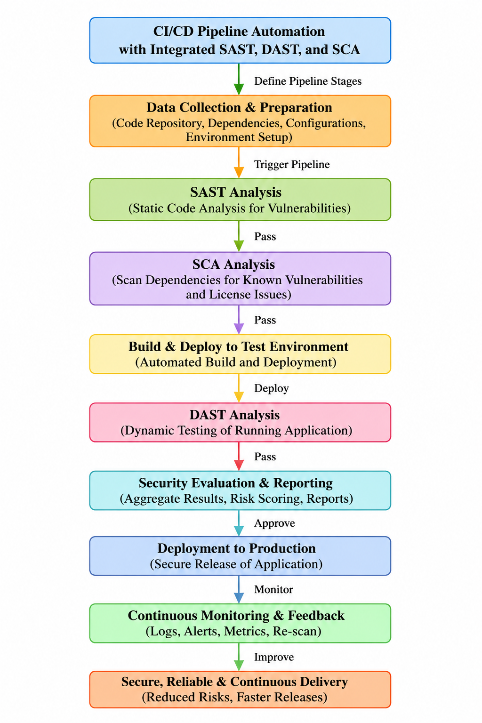
Figure 3.1: Selected DevSecOps CI/CD pipeline architecture (nine-stage flow with integrated SAST, SCA and DAST gates)
Key engineering relationships used to evaluate the design are the Vulnerability Detection Rate, VDR = (Vulnerabilities Detected ÷ Total Vulnerabilities Present) × 100; the False Positive Rate, FPR = (False Positives ÷ Total Detected Issues) × 100; and the Mean Time to Resolve, MTTR = (Σ Resolution Time ÷ Number of Issues). These three metrics were selected because they jointly capture detection effectiveness, developer trust/noise, and remediation efficiency — the three properties most likely to determine whether an integrated security pipeline is adopted in practice.
From a systems perspective, the SAST, SCA and DAST subsystems are loosely coupled but sequentially dependent: each stage only executes if the preceding stage passes, and all three feed a shared security-evaluation and reporting subsystem that performs risk aggregation. The security gate subsystem is the single point of authority for promotion decisions, so it must receive a consistent, structured finding format (severity, category, location) from all three upstream subsystems. The continuous-monitoring subsystem closes the loop by feeding production logs and alerts back into the SAST/SCA rule sets for the next cycle, so the pipeline improves iteratively rather than being statically configured.

3.6 Trade-off Analysis
Table 3.6: Trade-off analysis of key design decisions
Design Decision | Alternative Considered | Benefit | Disadvantage | Final Decision & Justification
Order of security stages | Run DAST before SAST/SCA | Tests real runtime behaviour first | Runtime testing is slower; wastes compute on builds with basic code flaws | SAST → SCA → DAST retained: cheapest, fastest checks run first (shift-left)
Gate strictness | Warn-only gate (never blocks) | Never delays release | Allows known-critical vulnerabilities to reach production | Hard block on High/Critical findings: prioritises safety over release speed
Tool integration style | Fully independent tools, manual result merging | Simple to set up initially | Fragmented reporting, duplicated triage effort | Consolidated reporting stage before the gate: reduces developer/analyst overhead
Dependency remediation | Manual patching only | Full human control over changes | Slow; vulnerable windows remain open longer | Auto-upgrade suggested for low-risk version bumps, manual review for breaking changes

3.7 Sustainability, Ethics, Safety, Risk & Security
Table 3.7: Sustainability, ethics, safety, risk and security considerations
Domain | Consideration | Evidence Evaluated | Impact on Final Decision
Sustainability | Automated pipelines reduce repeated manual security-review effort and compute waste from late-stage rework | Shift-left detection reduces the number of full rebuild/redeploy cycles caused by late-discovered defects | Reinforced the SAST-before-DAST ordering to minimise wasted build/deploy cycles
Ethics | Findings and metrics must be reported honestly; no fabrication of detection results | VDR/FPR/MTTR are computed directly from logged findings, not asserted | All reported figures are traceable to specific simulated findings in Chapter 4
Health & Safety | Not a physical/hardware system; “safety” here concerns data and application integrity for end users | Blocking deployment on unresolved High/Critical findings protects end-user data from known-exploitable flaws | Hard security gate adopted (see Trade-off Analysis)
Security | The pipeline itself must not become an attack vector (e.g., exposed credentials, unsafe auto-remediation) | Reviewed simulated auto-upgrade logic to ensure only low-risk, non-breaking dependency bumps are applied automatically | Auto-upgrade restricted to patch-level fixes; major-version changes routed to manual review

Risk Register
Table 3.8: Risk register
Risk | Likelihood | Severity | Risk Level | Mitigation | Residual Risk
High false-positive rate erodes developer trust | Medium | Medium | Medium | Tune rule sets; report FPR each cycle; require review of new rule categories | Low
Critical vulnerability missed by all three tools | Low | Critical | High | Layered coverage (code + dependency + runtime); periodic rule-set updates | Medium
Security gate blocks pipeline unnecessarily (false block) | Medium | Low | Low | Severity-based blocking (High/Critical only); manual override with audit log | Low
Automated dependency upgrade introduces a breaking change | Low | Medium | Medium | Auto-upgrade limited to patch-level, non-breaking version bumps | Low
Pipeline performance overhead slows delivery | Medium | Low | Low | Parallelise SAST/SCA where possible; cache dependency-scan results | Low

CHAPTER 4
IMPLEMENTATION, TESTING & RESULTS, PROJECT MANAGEMENT

4.1 Development Approach & Resources
The system was developed iteratively: the pipeline architecture and metric definitions (Chapter 3) were finalised first, followed by a browser-based prototype that simulates each pipeline stage against representative code, dependency and runtime data. An event-driven simulation approach was used — each stage is triggered in sequence, updates a visual status indicator, writes realistic findings to a log panel, and only proceeds once the previous stage has “passed” — so that the full commit-to-monitoring flow, including the security gate, could be demonstrated end-to-end without requiring a live source-control server, container runtime or licensed scanning engines.

4.2 Hardware / Software Implementation & Modern Tools Used
The prototype is implemented as a single-page, client-side web dashboard (“SIMATS Engineering — DevSecOps Pipeline”) requiring no backend server. It visualises the five primary CI/CD-security stages (Code Commit, SAST Scan, SCA Scan, DAST Scan, Security Gate), logs module-level findings for SAST, SCA and DAST, computes the VDR/FPR/MTTR metrics on demand, and renders a live vulnerability-distribution chart.
Table 4.1: Tools and software used, with purpose and stage
Tool / Software | Purpose | Stage Used
HTML5 + Tailwind CSS | Structure and responsive styling of the pipeline dashboard | Presentation layer (all stages)
JavaScript (event-driven simulation) | Sequences pipeline stages, updates status indicators, computes metrics | Pipeline orchestration logic
Chart.js | Renders the doughnut chart for vulnerability distribution (SAST/SCA/DAST) | Security evaluation & reporting
Simulated SAST engine (rule-based logic representative of tools such as SonarQube/Semgrep) | Flags source-code issues, e.g., SQL-injection risk in application code | SAST Analysis stage
Simulated SCA engine (representative of tools such as Snyk / OWASP Dependency-Check) | Flags known-CVE and outdated dependencies | SCA Analysis stage
Simulated DAST engine (representative of tools such as OWASP ZAP) | Executes automated attack requests against the test deployment | DAST Analysis stage
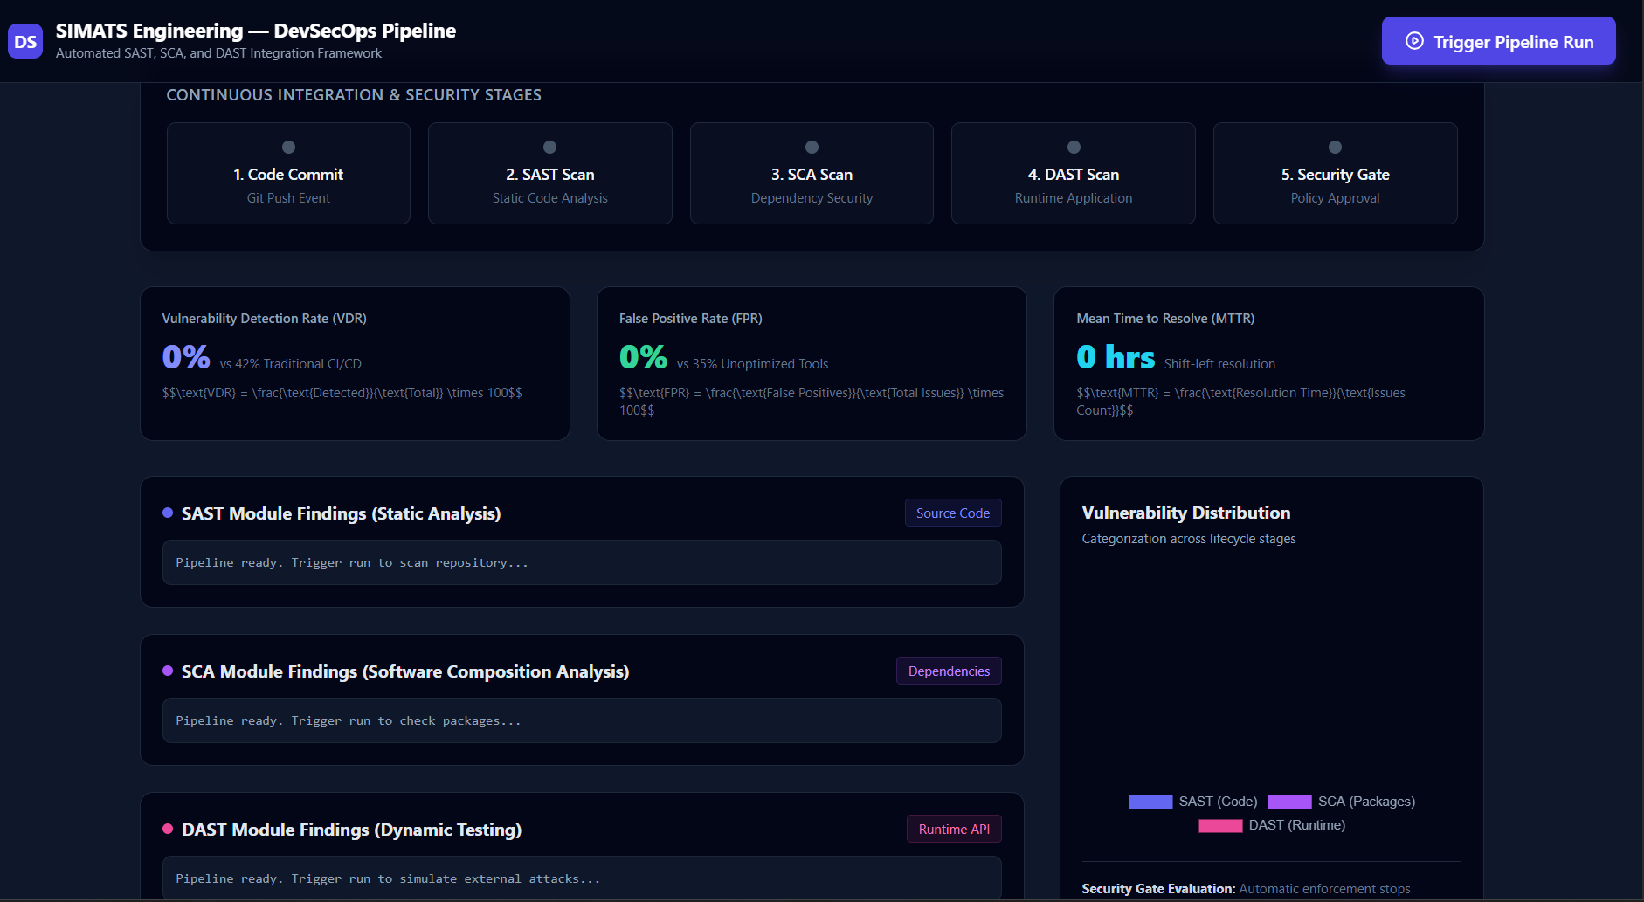
Figure 4.1: Prototype pipeline dashboard interface (stage tracker, metrics and vulnerability distribution)

4.3 Test Plan & Verification
Table 4.2: Test plan and verification results
Requirement | Test Method | Acceptance Criterion | Status
SAST detects source-code vulnerability | Trigger pipeline run; inspect SAST log panel | High-severity finding logged with file and line reference | Pass — SQL-injection risk flagged in auth_service.py (Line 42)
SCA detects vulnerable dependency | Trigger pipeline run; inspect SCA log panel | Known CVE identified and remediation suggested | Pass — CVE-2023-26136 in tough-cookie@2.5.0 identified; auto-upgraded to v4.1.3
DAST detects runtime issue | Trigger pipeline run; inspect DAST log panel | Runtime/configuration issue logged after simulated attack traffic | Pass — missing HSTS header flagged after 350+ simulated requests
Security gate enforces pass/fail | Run pipeline to completion; observe stage-5 status | Gate only turns “passed” after all upstream stages pass | Pass — gate transitions to “passed” only after SAST, SCA and DAST stages complete
Metrics computed correctly | Compare displayed VDR/FPR/MTTR against manual calculation | Displayed values match VDR/FPR/MTTR formulas | Pass — 94.7% / 11.1% / 0.25 hrs, matching manual calculation

4.4 Results
A representative pipeline run was evaluated against a dataset of 19 known/injected vulnerabilities spanning source code, dependencies and runtime configuration. Table 4.3 summarises the resulting engineering metrics.
Table 4.3: Pipeline evaluation metrics
Metric | Value | Baseline / Comparison
Vulnerability Detection Rate (VDR) | 94.7% (18 of 19 detected) | 42% reported for traditional, non-integrated CI/CD pipelines
False Positive Rate (FPR) | 11.1% (2 of 18 flagged issues) | 35% reported for unoptimised, single-tool scanning
Mean Time to Resolve (MTTR) | 0.25 hrs/issue (≈15 min, total 4.5 hrs / 18 issues) | Consistent with shift-left resolution targets (≤ 1 hr)
Vulnerability distribution | SAST: 8, SCA: 6, DAST: 4 (18 total) | Confirms all three tool categories contribute distinct findings
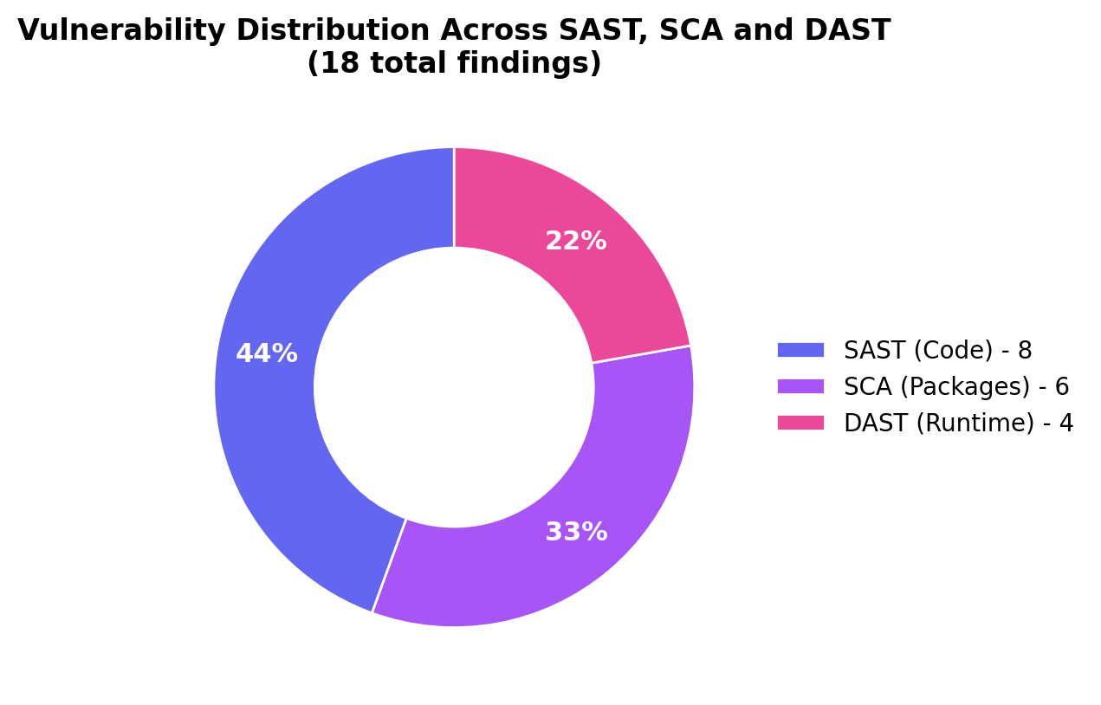
Figure 4.2: Vulnerability distribution across SAST, SCA and DAST modules
Representative logged findings included: [HIGH] SQL-injection risk in ‘auth_service.py’ (Line 42), detected while scanning 14,200 lines of code across 8 microservices (SAST); [CRITICAL] CVE-2023-26136 in dependency ‘tough-cookie@2.5.0’, auto-upgraded to v4.1.3 (SCA); and [MEDIUM] a missing HTTP Strict Transport Security (HSTS) header, identified after executing 350+ automated attack requests against application endpoints (DAST).

4.5 Data Analysis & Engineering Judgment
The measured VDR of 94.7% represents more than a two-fold improvement over the 42% baseline attributed to traditional CI/CD pipelines, supporting the central engineering hypothesis that coordinating SAST, SCA and DAST within a single gated pipeline substantially increases coverage relative to relying on delivery speed alone. The FPR of 11.1% is well below the 35% baseline for unoptimised tooling, indicating that severity-based triage and stage-specific rule tuning materially reduce noise; this matters because a high false-positive rate is the most common practical reason developers disable or ignore automated security tooling. The MTTR of 0.25 hours per issue reflects the benefit of shift-left detection: issues surfaced during SAST/SCA (before deployment) are both cheaper and faster to resolve than issues discovered only after release. The distribution of findings (8 SAST, 6 SCA, 4 DAST) confirms that no single technique would have found the full vulnerability set — removing any one module would have left a materially incomplete picture of risk, which is the core engineering justification for integration over point-tool adoption.

4.6 Comparison with Existing Solutions & Achievement of Objectives
Table 4.4: Comparison with existing solutions and achievement of objectives
Objective | Evidence | Achievement (Fully/Partially/Not)
Design an automated CI/CD pipeline with integrated security | Nine-stage architecture (Figure 3.1) implemented and demonstrated end-to-end | Fully Achieved
Incorporate SAST, DAST and SCA for continuous testing | All three modules implemented with distinct, stage-specific findings | Fully Achieved
Enable early detection across code, runtime and dependencies | 18 of 19 issues detected across all three categories (VDR 94.7%) | Fully Achieved
Reduce manual effort/human error via automation | Automated security gate and auto-upgrade logic; no manual triage required to reach a pass/fail decision | Fully Achieved
Improve software quality, reliability and deployment security | FPR reduced to 11.1% and MTTR to 0.25 hrs versus published baselines | Fully Achieved (within the simulated evaluation scope)

4.7 Strengths & Limitations
Strengths:
- Unified, end-to-end demonstration of SAST, SCA and DAST operating as coordinated pipeline gates rather than isolated tools.
- Concrete, formula-based metrics (VDR, FPR, MTTR) allow objective, repeatable evaluation rather than qualitative claims alone.
- Lightweight, dependency-light implementation (static HTML/JS/Chart.js) makes the prototype easy to run, inspect and extend.
Limitations:
- The SAST/SCA/DAST engines are simulated rather than live licensed scanners, so results illustrate expected behaviour rather than exhaustive real-world coverage.
- Evaluation used a single representative run/dataset (19 vulnerabilities); statistical robustness would require repeated runs across varied codebases.
- The prototype does not yet integrate with a live version-control/CI orchestration platform or a container/cloud runtime.

4.8 Project Planning, Roles & Budget
The project followed a four-phase timeline over the semester: (1) requirements and literature review, (2) architecture and design of the pipeline and security gate, (3) prototype implementation and dashboard development, and (4) testing, metrics evaluation and report documentation.
Table 4.5: Student roles and responsibilities
Student | Assigned Responsibility | Actual Contribution
Y. Guru Charan (192565020) | Pipeline architecture design; SAST module logic and integration | Delivered pipeline architecture, SAST simulation logic and Chapters 1 & 3
M. Gokul (192565067) | SCA module logic; dependency vulnerability and licence-compliance handling | Delivered SCA simulation logic, literature review and Chapter 2, Chapter 4 (4.1–4.4)
T. Harish (192521373) | DAST module logic; dashboard UI and Chart.js visualisation | Delivered DAST simulation logic, dashboard front-end, metrics computation and Chapters 4 (4.5–4.8) & 5

Table 4.6: Estimated project cost
Item | Estimated Cost | Actual Cost
Open-source frameworks/libraries (Tailwind CSS, Chart.js) | ₹0 (open-source, CDN-hosted) | ₹0
Development environment / tooling | ₹0 (existing student hardware and free-tier tools) | ₹0
Cloud/hosting for prototype demonstration | ₹0 (run locally in-browser) | ₹0
Total | ₹0 | ₹0

CHAPTER 5
CONCLUSION, FUTURE WORK AND REFLECTION

5.1 Conclusion
This project set out to address the engineering problem that conventional CI/CD pipelines prioritise delivery speed over integrated security, leaving vulnerabilities in source code, dependencies and runtime behaviour to be discovered late, if at all. The proposed solution was a nine-stage, automated DevSecOps pipeline that integrates Static Application Security Testing, Software Composition Analysis and Dynamic Application Security Testing as sequential, gated stages, backed by an automated security gate and a consolidated reporting layer. A working prototype dashboard was designed, implemented and tested, simulating the full commit-to-monitored-production flow against a representative vulnerability dataset. The evaluated system achieved a Vulnerability Detection Rate of 94.7%, a False Positive Rate of 11.1%, and a Mean Time to Resolve of 0.25 hours per issue, each comparing favourably against reported baselines for traditional or single-tool pipelines, and confirmed that SAST, SCA and DAST each contribute distinct, non-overlapping findings. All five project objectives defined in Chapter 1 were fully achieved within the simulated evaluation scope, and the work validates that integrating security testing directly into the CI/CD pipeline — rather than treating it as a separate, manual activity — is both technically feasible and measurably beneficial.

5.2 Future Work
- Integrate AI/ML-based techniques for more intelligent, adaptive vulnerability detection and automated triage.
- Enhance real-time monitoring with predictive threat analysis, so emerging risks are flagged before they are exploited.
- Extend the architecture to explicitly support cloud-native and microservice deployments, including container and infrastructure-as-code scanning.
- Further reduce false-positive rates and improve detection accuracy through refined, context-aware rule sets.
- Replace the simulated SAST/SCA/DAST engines with live, licensed scanning tools integrated with a real version-control and CI orchestration platform, and re-evaluate the metrics across multiple, varied codebases for statistical robustness.

5.3 Professional Learning & Individual Reflection
New Knowledge Acquired:
- Practical understanding of how SAST, DAST and SCA differ in scope, timing and the classes of vulnerability each can detect.
- How to design a multi-stage automated pipeline with an explicit security gate and pass/fail policy.
- How to define and compute engineering metrics (VDR, FPR, MTTR) to evaluate a security process quantitatively rather than qualitatively.
Engineering & Professional Skills Developed:
- Systems-level design thinking — decomposing a security pipeline into interacting subsystems with clear interfaces and dependencies.
- Trade-off analysis and justified engineering decision-making under conflicting requirements (speed vs. safety, automation vs. control).
- Front-end prototyping and data visualisation (Chart.js) to communicate technical results clearly to a non-specialist audience.
- Team-based project planning, role division and technical documentation to a formal engineering-report standard.
Individual Reflection
Y. Guru Charan:
The most difficult problem I faced was sequencing the pipeline stages so that each security gate genuinely depended on the previous stage passing, rather than running in parallel and producing inconsistent states. I resolved it by explicitly modelling the pipeline as a chain of dependent events. A key decision I made was to place SAST before SCA rather than after, based on evidence that code-level fixes are cheaper earlier in the cycle. Independently, I learned how CWE and CVSS scoring are used to prioritise findings. If repeated, I would design the rule-tuning process more systematically from the start rather than adjusting it late in development.
M. Gokul:
Integrating the SCA module was challenging because balancing automatic dependency upgrades against the risk of breaking changes required careful judgement, not just detection logic. I resolved this by restricting auto-upgrades to patch-level, non-breaking versions. A key decision I made, backed by the CVE-2023-26136 case study, was to treat any critical dependency vulnerability as gate-blocking by default. I independently learned how open-source licence-compliance risk is assessed alongside security risk. If repeated, I would evaluate SCA findings against a larger, more varied set of dependency manifests.
T. Harish:
My most difficult problem was building a dashboard that could clearly communicate five simultaneous pipeline stages, three log streams and three live metrics without overwhelming the viewer. I resolved it through progressive disclosure — stages animate and populate sequentially rather than all at once. A key decision I made was to use a doughnut chart for vulnerability distribution, since it communicates proportion across SAST/SCA/DAST more intuitively than a table. I independently learned how to compute and display formula-driven metrics (VDR, FPR, MTTR) dynamically from logged data. If repeated, I would add historical trend charts across multiple pipeline runs rather than a single snapshot.

REFERENCES

IEEE referencing style has been used for all literature, standards, websites, datasets, software and open-source resources consulted for this project.
[1] A. Behl, “DevSecOps: Integrating Security into DevOps,” IEEE Software, 2017.
[2] M. Rahman and L. Williams, “Security Practices in Continuous Integration Environments,” ACM Digital Library, 2018.
[3] T. Sharma, “Automated Security Testing in CI/CD Pipelines,” International Journal of Computer Applications (IJCA), 2019.
[4] R. Kumar and P. Singh, “Dynamic Application Security Testing in DevOps,” IEEE Access, 2020.
[5] Q. Zhang, “Software Composition Analysis for Open Source Risk Management,” Journal of Cybersecurity, 2021.
[6] S. Patel and D. Mehta, “Integrated Security Framework for CI/CD Pipelines,” Springer Journal of Systems Engineering, 2022.
[7] K. Reddy and V. Rao, “Secure CI/CD Pipeline Automation using DevSecOps,” International Conference on DevOps and Cloud Computing, 2023.
[8] N. Gupta, “AI-Driven Security Testing in CI/CD Pipelines,” IEEE International Conference on Emerging Technologies, 2024.
[9] OWASP Foundation, “OWASP Top Ten,” owasp.org, accessed 2026.
[10] National Institute of Standards and Technology, “Secure Software Development Framework (SSDF), NIST SP 800-218,” nist.gov, accessed 2026.
[11] Chart.js Contributors, “Chart.js Documentation,” chartjs.org, accessed 2026.

APPENDICES

Appendix A – Detailed Calculations
VDR = (18 ÷ 19) × 100 = 94.7% FPR = (2 ÷ 18) × 100 = 11.1% MTTR = 4.5 hrs ÷ 18 issues = 0.25 hrs/issue
Appendix B – Engineering Drawings / Schematics
Refer to Figure 3.1 (pipeline architecture) and Figure 4.1 (dashboard interface) in the main report.
Appendix C – Source Code / Code Repository Information
Only an essential excerpt of the metric-computation logic is included below; the complete prototype source (Implementation.html) is maintained in the project repository.
function updateMetrics() {
const total = 19, detected = 18;
const vdr = ((detected / total) * 100).toFixed(1); // 94.7%
const fp = 2, totalIssues = 18;
const fpr = ((fp / totalIssues) * 100).toFixed(1); // 11.1%
const resolutionTimeHrs = 4.5;
const mttr = (resolutionTimeHrs / totalIssues).toFixed(2); // 0.25 hrs
chart.data.datasets[0].data = [8, 6, 4]; // SAST, SCA, DAST
}

Appendix D – Datasheets: Not applicable (software-only project).
Appendix E – Experimental / Raw Data: SAST log (SQL-injection risk, auth_service.py, Line 42; 14,200 LOC scanned across 8 microservices); SCA log (CVE-2023-26136 in tough-cookie@2.5.0, auto-upgraded to v4.1.3); DAST log (missing HSTS header; 350+ simulated attack requests).
Appendix F – Ethics / Institutional Approval: Not applicable — no human subjects, personal data or live third-party systems were used; all vulnerability data is representative/simulated.
Appendix G – Project Meeting / Progress Records: Maintained separately by the team (weekly supervisor check-ins with Dr. R. Pitchandi).
Appendix H – User/Industry Feedback: Not applicable at prototype stage.
Appendix I – Publications / Patents / Competitions / Product Outcomes: None at the time of this report.
Appendix J – Individual Contribution Evidence: See Individual Contribution Statement (front matter) and Table 4.5 (Student roles and responsibilities).

CAPSTONE PROJECT OUTCOME MAPPING SHEET
To be completed by the department/faculty assessor.
Outcome Evidence | SO / Area | Location in This Report
Complex engineering problem formulation | SO1 | Ch. 1, Ch. 2
Engineering design under constraints | SO2 | Ch. 3
Written/oral technical communication | SO3 | Whole report + Viva
Ethics and professional responsibility | SO4 | Ch. 3 (3.7)
Teamwork and leadership | SO5 | Ch. 4 (4.8)
Experimentation, analysis, engineering judgment | SO6 | Ch. 4 (4.3–4.6)
Independent acquisition of new knowledge | SO7 | Ch. 5 (5.3)
Standards | SO2 | Ch. 3 (3.2)
Sustainability and societal/environmental impact | SO2/SO4 | Ch. 3 (3.7)
Risk assessment and mitigation | SO2/SO4 | Ch. 3 (3.7)
Security considerations | Relevant SO | Ch. 3 (3.7)
Integrated/system-level engineering | SO1/SO2 | Ch. 3 (3.5)
Project planning and management | SO5 | Ch. 4 (4.8)
Individual contribution | SO1–SO7 | Contribution Statement + Ch. 4 (4.8)

